**1.QuickSort**

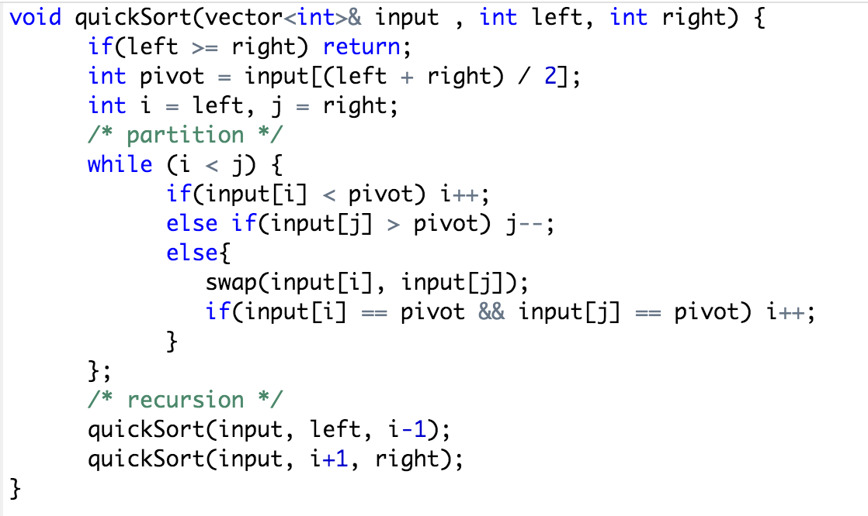

**2.Merge k Sorted List (MergeSort)**

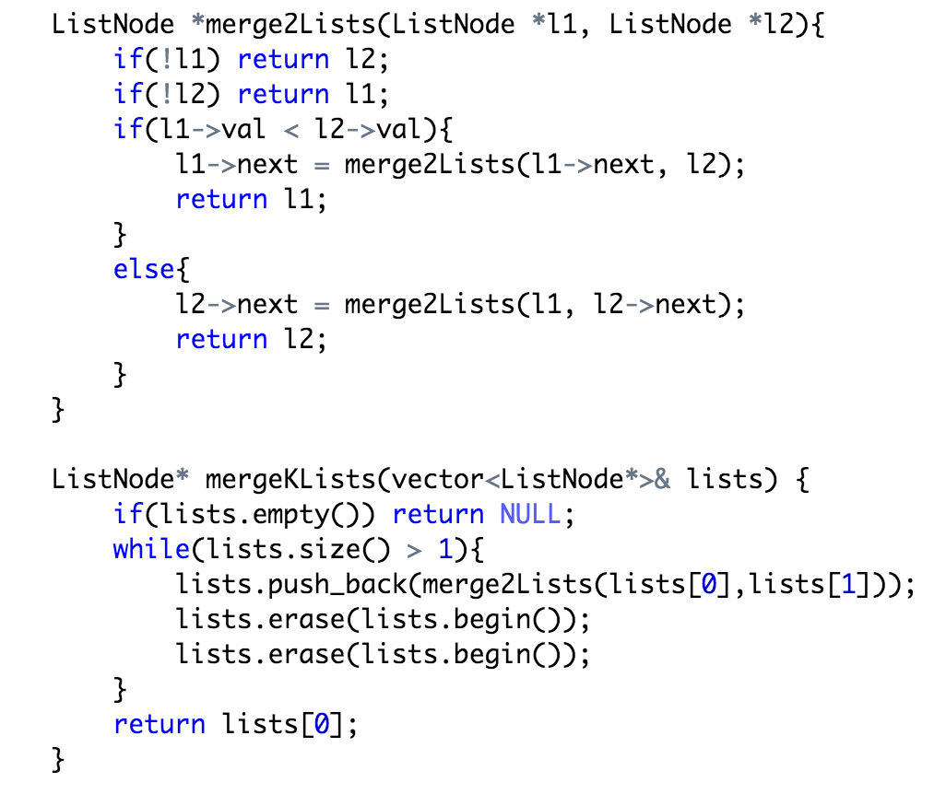

**3.Merge k Sorted List (HeapSort)**

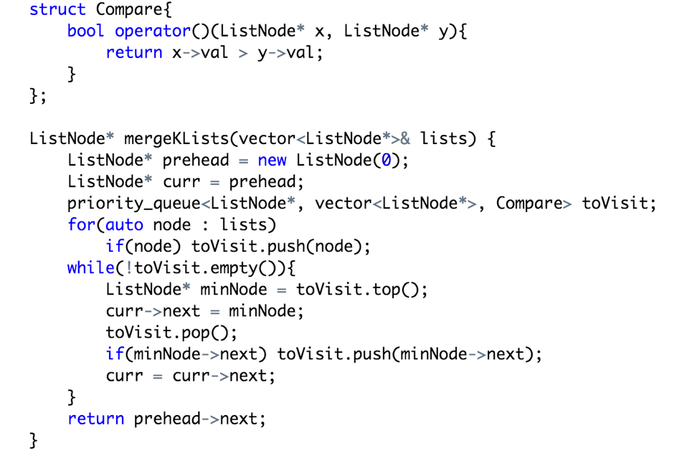

**4. count sort**

Sort 10million 8 bit unsigned int.

8bit = 256 = 1 byte, use a long[256]

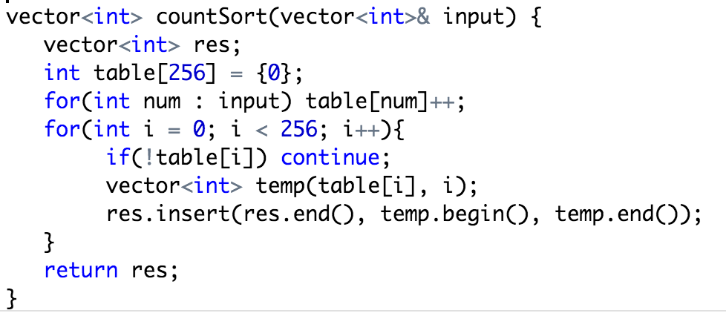

10million的item class，item有rating和name, rating是8bit unsigned int

vector<vector<*Item>>, 把rank相同的，放到同一个vector下

Given an array of 1 million integers representing age of people in a city.

Vector<vector<*People>>, 把same age的放在同一vector下

**5. sort(int a, int b, int c)**

